*Florida International University*

*School of Computing and Information Sciences*

Software Engineering Focus

Feature Document

User Story ID <NVOS-40 View PDF>

**Name:** Bryan Bastida

**Team Member(s):** Bryan Bastida

Andrew Castillo

**Project:** Envo Scholar

**Product Owner(s)**: Mark Finlayson

**Mentor(s)**: Masoud Sadjadi

**Instructor**: Masoud Sadjadi

**User Story Name:** View PDF

Description: As a user, I want to click a button that links to the PDF result, so that I can view the PDF.

Acceptance Criteria

* User entered a search query
* Database successfully returned articles related to the search
* Article links are displayed on the screen
* User pressed button to view PDF
* PDF file opens on a new page

**Use Case**

* **Name**: View PDF
* **Actor**: User and web page
* **Preconditions**: Article links are displayed on web page as well is link for View PDF
* **Description** <Flow of events>:
  + User types a search query and hits the Search button
  + Search query is sent to the database
  + Database returns articles
  + Web page displays article links and link for View PDF
  + User hits the View PDF link
  + The PDF opens on a new window

**Use Case Diagram**

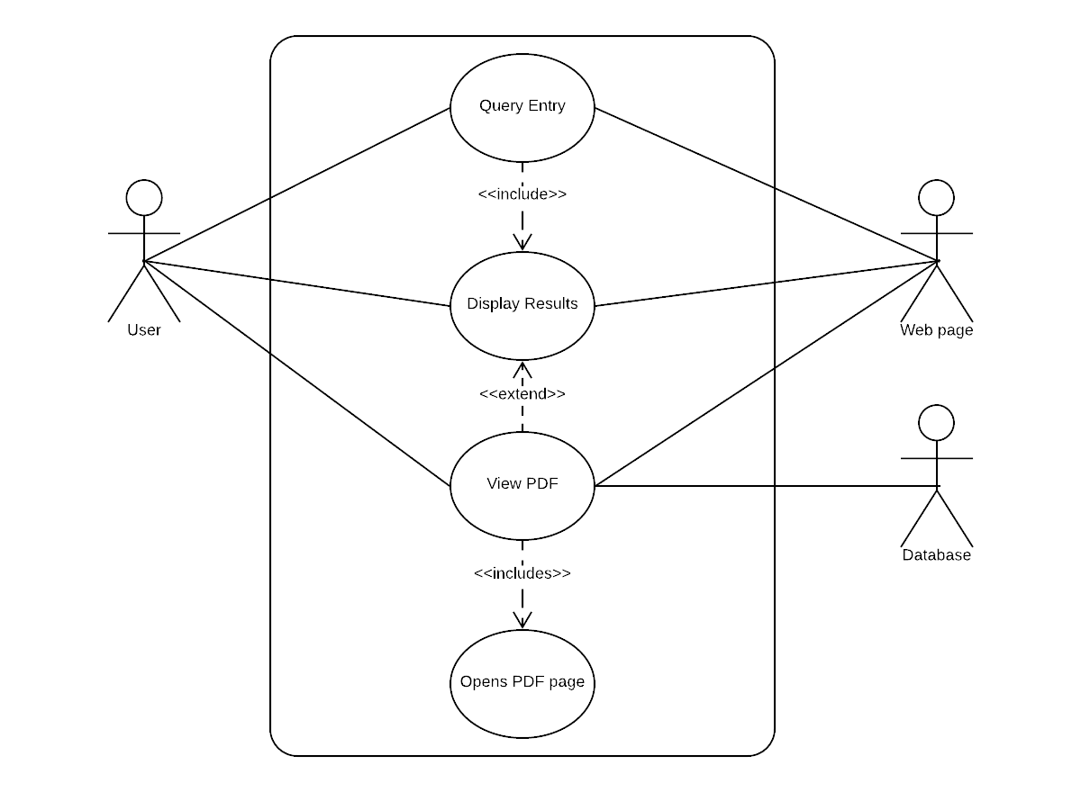

**Sequence Diagram**

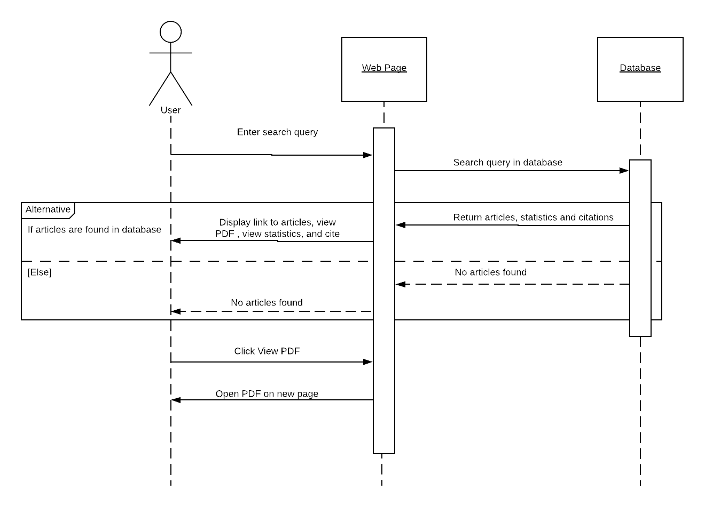

**Class Diagram**

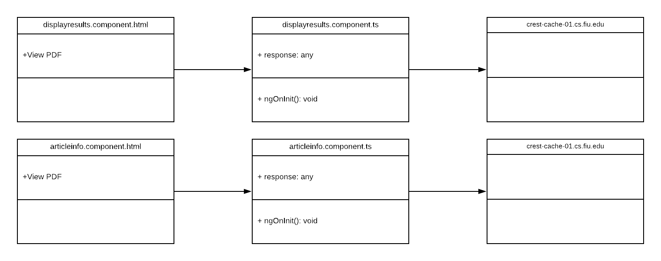

## ****Unit Test****

* Test case ID: NVOS-40-View-PDF
* Description/Summary of Test: This test was to check that a PDF page will open when the user clicks on View PDF.
* Pre-condition: User has searched for an article. User is now on the displayresults page and is hovering over the View PDF link on an article. User clicks on the View PDF.
* Expected Results: Science Direct page with PDF of that article opens on a new tab.
* Actual Result: Science Direct page with PDF of that article opened on a new tab.
* Status (Fail/Pass): Pass

**Visual User Guide**

